On 5/13/14 Adam Stetten performed a detailed review of the water impact to this residence. Various other aspects of improvement, such as plumbing, and HVAC were analyzed. Please review the photos below. Some of the photos are for our purposes, of conveying information to our various subcontractors, and some of the photos are meant to show just how crazy the access, plumbing, HVAC really is. Please let us know if you have any questions.
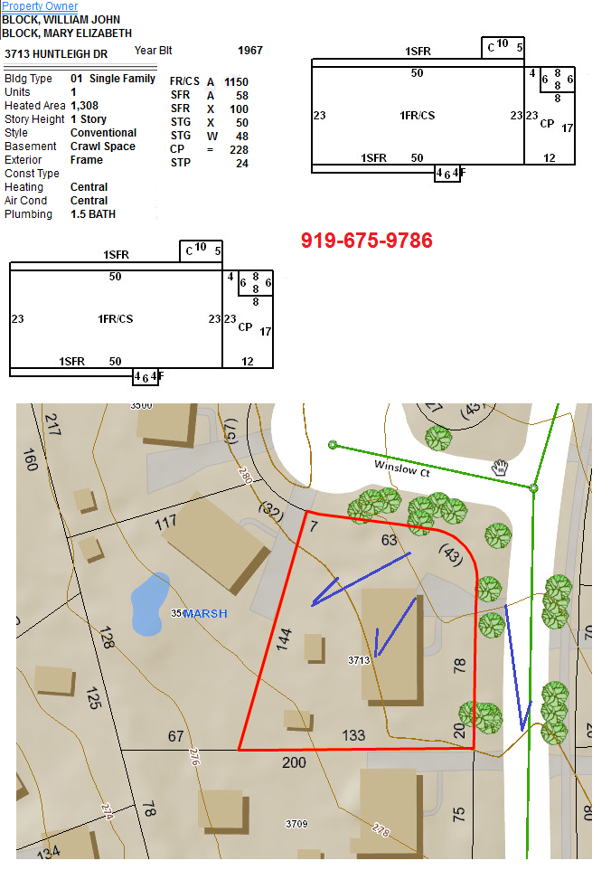
Sincerely, Adam Stetten
Wake County TOPOGRAPHY

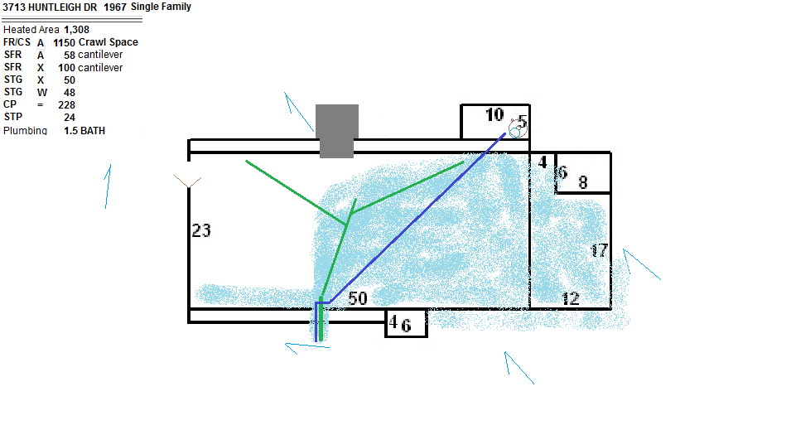
Existing Water Impact

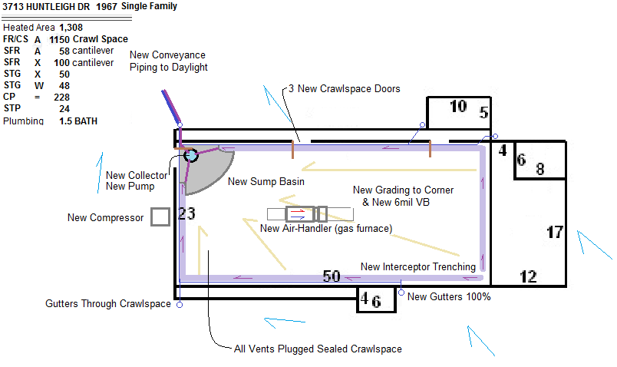
Potential Future Layout / Features

