Finalized Date: OCTOBER 26th 2013

Finalized Location: South Dacian Rd.
Dacian Road is in Southeast Raleigh, and at its south most stretch, it is a dead end. The “one way in/one way out” works for our ice-cream-truc- stake-out most effective for attracting a higher percentage of the last section, South of GREYSON STREET.
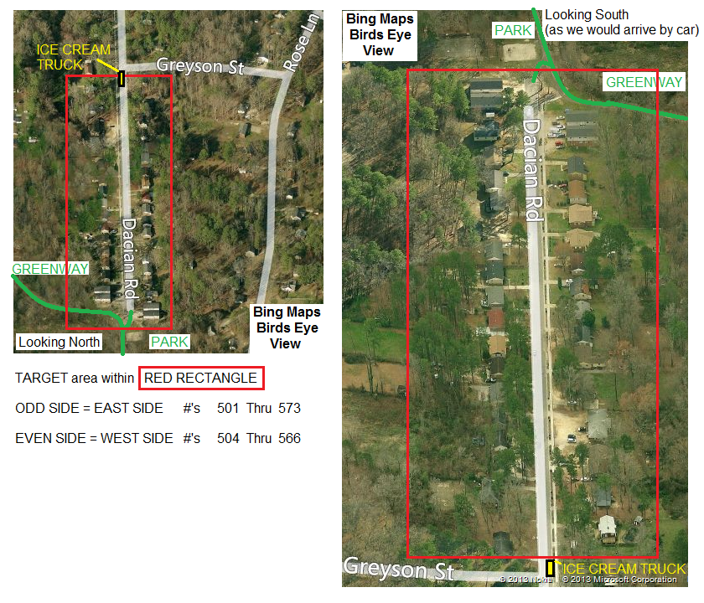

Program Outline:
We need to develop DOOR HANGERS for all homes and currently I am counting 31 Deeded Parcels on this Street. This may mean there is up to 45 Individual Units. More investigation needed. We need to develop a mailer for the non-owner occupied homes that goes to the owner’s mailing address. Some busy work needed on Wake.Gove to Fill in an Excel Document Adam has started.
Starting September 30th we will be Marketing our Event to attract volunteers from our core of
EMERGING PROFESSIONALS, and those INVOLVED WITH THE ORGANIZATION.
Our goal is 25 people to work the 26th who have been trained via a prior event? or conference call , or via email
(Adam to work on training materials).
On Saturday 12th and 19th we will be in the community with one or two teams of 4 volunteers. Each team to include a Spanish Speaker, Designated Photo Documenter, Designated Note-Taker, and a Technician Type Person to stage photos of Light Fixtures, Attic Access Doors, Leaky Windows and Doors, Bath-Fan housings, Supply Duct Boots, Leaky Duct-Work if applicable, etc. During these site visits we need professional looking multi-lingual collateral, including door-hangers, flyers, etc. Does anyone think we need to be in some kind of uniform? Maybe we can just got for Jeans, Running Shoes, and a White Polo Shirt, and NAME TAGS?
Goals to be aware of /Things we need to be great at:
1) All of the work we do should be good for the community, and should be serving us in the future(for at least the next 5 years) as we develop strategies and skills for our branch, chapter, and other chapters in the SERC.
2) attracting the community residents with ice-cream and/or refreshments
3) obtaining access to 24 months past energy bills and all future energy bills
4) continual outreach to residents to keep them in our queue, and us in their minds
5) Develop Instructional Videos and/or PDF’s for:
5.1) Remove, Dispose/Recycle old light bulbs SAFELY
5.2) Install and Test new light bulbs SAFELY
5.3) Tighten Up and Re-Insulate ATTIC ACCESS LADDERS and SCUTTLES - SAFELY
5.4) Seal Bath Fan Housings to Drywall, Duct-Boots to Drywall - EFFECTIVELY
5.5) Seal Duct boots to sub-floor – Using Tape or Mastic Effectively
5.6) To inspect Duct-Work for Leakage and General Photo-Documentation Rules
6) Proficient Upgrading with donated bulbs, and to (while we are there) photo-document other low hanging fruit such as Attic Access Doors, Leaky Windows and Doors, Bath-Fan housings, Supply Duct Boots, Leaky Duct-Work if applicable, etc.
7) Plan and Prepare for Training Events for VOLUNTEERS to get everyone is on the same unified page.
5) We need a budget for Cameras and related Supplies. I recommend Water-Proof, Dust-Proof, Shock-Proof, Freeze Proof cameras because they have no moving parts, which tends to extend battery life greatly, and they fit in your pocket so you’ll always be ready for the money-shot.

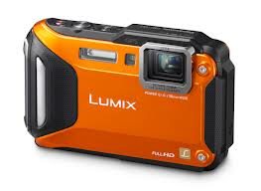
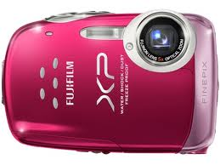
This is what I carry 24/7

This would work

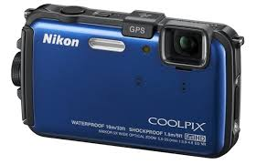
this would also work and it would tag the pictures with GPS which is awesome.
The problem with smart phones is weak flash.

Another thought is to buy even cheaper cameras with AA batteries so we can not worry about having stuff charged.
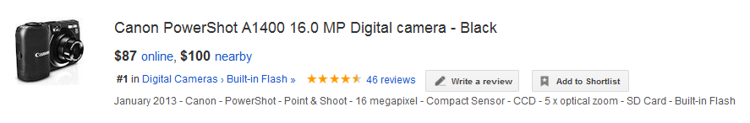
If I was extremely wealthy I would buy 5 of these canon A1400 cameras and 10 8GB SD memory cards and 50 AA Batteries and gift them to the project but I am sure we could make do with volunteer cameras. It is crucial that we are consistent with pictures, and efficient and turning in cards for photo-upload and annotation. 16MP is over-kill because 640x480 is roughly 0.3MP which is the recommended setting for photo-documentation.

Draft Homeowner Questionnaire: NEEDS TO BE TRANSLATED and EDITTED SOON
Names of adults residing in the home.
Address of the home
Phones and Emails for all adults
Number of children or other occupants
# of pets and description of pets, friendly?
Spoken Languages:
Electricity and Gas Account Numbers – Release Form for Energy Data
NOTE! We want to convert all usage to DOLLARS per SQUARE FOOT per YEAR
Waiver of Liability,
Number of bedrooms, bathrooms, square footages,
(We should always print the Wake County Tax Record Building Information Page prior to each visit)
How many Fridges or Freezers do you have?
Do you tend to keep your interior doors open or closed when away from home? When sleeping?
Are the Air-Conditioning Vents in the Ceiling or the Floor of your home?

Materials List: STUFF THAT USGBC NC SHOULD BUY?
- Name Tags, Sharpies, Marketing Materials, Business Cards
- Small digital camera with battery and empty SD cards
(and list of critical photos needed for each home visit)
- Protective gear if not donated

Materials List: STUFF THAT SHOULD BE DONATED? Volunteers Bring?
- Protective Gear
- Trash bags
- dust pan and brush
- Drop-cloths
- Bucket with basic tools:
drill with extra batteries & Phillips, Hex, Flat-Head bits, screwdrivers with same Phillips, hex, and flat-heads bits or a 6-way screwdriver, Tape-measures, hammer(small hammers are good too), razor knives, scissors, clip-board, pens pencils, staple gun and staples, headlamps, flashlights, batteries,
- Bucket with basic supplies:
variety of tapes, squeeze caulks, weather-stripping, expanding foam,
- Tool Bags
- Rolling Cart with a variety of different light-bulbs
- 6’ ladder and 4’ladder
- Knee-pads, dust-masks, coveralls for inspecting attics or crawlspaces

Materials List: STUFF THAT ADAM CAN PROVIDE?
- PRODEX for insulating attic ladders and scuttles
- At least two sets of basic tools
- 6’ ladder
- 4’ ladder

Volunteer Jobs:
Light Bulb Donations (Cree?) - Jeff/Laura
Get Home Depot/Lowes Donation (see list above) - Jeff & ... (Adam to provide qtys)
50 Green Tool Vest with USGBC NC logo (similar to lowes/home depot employees) - educational outfitters?? Paul
Ice Cream/lunch - Candis - does the guy show up 11-12
Volunteer recruitment letter & website info - will to send to adam for feedback
- Volunteers to commit to 1 saturday in early october to attend training and pass out door hangers to generate interest as well as 10/26 event.
Draft instructional Videos? - shoot on 10/12?
Will/adam to email brad wood for duke energy/progress connection

