Dacian Road – Door Hangers –

DRAFT needs formatting and editing
Congratulations! Your home has been selected for FREE Energy Efficient Light-Bulb Replacement. On October 26th we will be in your community to switch out your bulbs, & your family is invited to enjoy Free Ice-Cream.
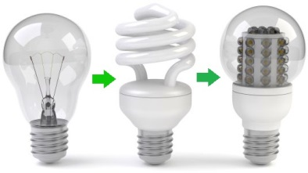
All you have to do is share your Duke Energy Progress Usage info with us and you will soon be saving about $40 to $80 per light bulb!

Help us count your Light-Bulbs:
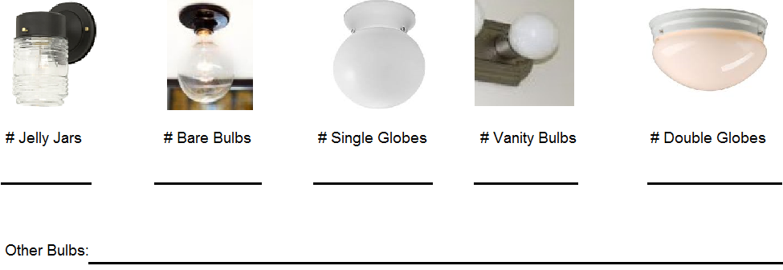
Address:
Electricity Account Number:
????????????????????????? Questions Comments Concerns?

